

Assignment for Excel and Tableau

**content**

**introduction to data policies……………………………page 1-2**

**excel work…………………………………………………………page 3-7**

**tableau charts……………………………………………………page 8**

**WHY DATA SCIENCE MATTERS TO PUBLIC POLICY AND GOVERNANCE**

Evaluating data is becoming a core component of government oversight. The actions of private companies are more frequently in databases than file cabinets, and having that digital information obscured from regulators will undermine our societal safeguards. Government agencies should already be acting to evaluate [problematic AI-hiring software](https://www.brookings.edu/blog/techtank/2019/10/31/for-some-employment-algorithms-disability-discrimination-by-default/) and seeking to uncover biases in models that [determine who gets health interventions](https://www.theguardian.com/society/2019/oct/25/healthcare-algorithm-racial-biases-optum). As algorithmic decision-making becomes more common, it will be necessary to have a core of talented civic data scientists to [audit their use in regulated industries](https://www.brookings.edu/research/ethical-algorithm-design-should-guide-technology-regulation/).

Even for public servants who never write code themselves, it will be critical to have enough data science literacy to meaningfully interpret the proliferation of empirical research. Despite recent setbacks—such as proposed [cuts to evidence-building infrastructure](https://twitter.com/NickRHart/status/1226928062316601346) in the Trump administration’s budget proposal—evidence-based policymaking is not going anywhere in the long term. There are already 125 federal statistical agencies, and the Foundations of Evidence Based Policymaking Act, passed early last year, expands the footprint and impact of evidence across government programs.

**“Even for public servants who never write code themselves, it will be critical to have enough data science literacy to meaningfully interpret the proliferation of empirical research.”**

Further, the mindset of a data scientist is tremendously valuable for public servants: It forces people to confront uncertainty, consider counterfactuals, reason about complex patterns, and wonder what information is missing. It makes people skeptical of anecdotes, which, while often emotionally powerful, are not sufficient sources of information on which to build expansive policies. The late and lauded Alice Rivlin knew all this in 1970, when she published “[Systemic Thinking for Social Action](https://www.brookings.edu/book/systematic-thinking-for-social-action-2/).” Arguing for more rigor and scientific processes in government decision-making, Rivlin wrote a pithy final line: “Put more simply, to do better, we must have a way of distinguishing better from worse.”

*How to encourage data-scientific thinking and evidence-based policies*

The tools and data to distinguish better from worse are more available than ever before, and more policymakers must know how to use and interpret them. A continued expansion of evidence-based decision-making relies on many individuals in many different roles, adopting practices that encourage data-scientific thinking. Managers in government agencies can hire analysts with a rigorous understanding of data in addition to a background in policy. They can also work to open up their datasets, contributing to Data.gov and the [broader evidence-based](https://www.data.gov/open-gov/) infrastructure. Grant-making organizations have a critical role, too. They should be mandating an evaluation budget—at least 5% of a grant—to collect data and see if the programs they are funding actually work. When they fund research, it should require replicable research and open-data practices.

task 1 protecting the workbook

task 2 display columns c in British pound

task 3 make data into a table

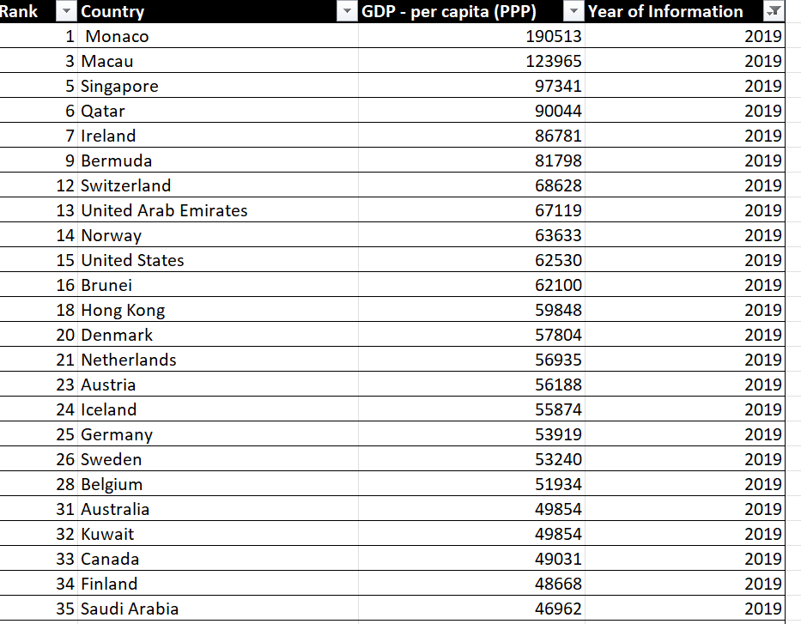Task 4 filter 2019

Task 5 make a chart

Task 6 make the chart visually pleasing.

Task 7 separate sheet

Task 8 top 20 sorting

Task 9 make a chart for top 20

Task 10 colouring the chart

https://public.tableau.com/views/top20_16825938819440/Dashboard1?:language=en-GB&publish=yes&:display_count=n&:origin=viz_share_link